

PROJECT REPORT - PRN232

Software Requirement Specification

PrintHub: Web-Based Multi-Vendor Printing & Fabrication Service Marketplace

Ngô Minh Nhật - HE190217- SE1909 .NET

Table of Contents

I. Record of Changes 4
II. Definition 4
1. Acronyms 4
2. List Figures and Tables 6
2.1 List Figures 6
2.1 List Tables 6
3. Legend 6
3.1 System Context Diagram 6
3.2 Use Case Diagram 7
3.3 Screen Flow 8
3.4 Entity Relationship Diagram 9
3.5 Main Workflows 11
III. Project Specification 12
1. Project Introduction 12
1.1. Project Name 12
1.2. Objectives 12
1.3. Scope 12
1.4. System Context Diagram 13
2. User Roles 15
3. Use Cases 16
3.1. Use Case List 16
3.2. Use Case Diagram 24
4. ERD and Database Schema 25
4.1. Main Entities 25
4.2. Entity Relationship Diagram 26
4.3. Important Database Constraints 26
5. Business Rules 27
6. Workflows 28
6.1. Order Workflow 29
6.2. Shop Onboarding Workflow 29
7. System Architecture 30
7.1. Architecture Diagram 30
7.2. Layer Responsibilities 30
8. Service Design 31
9. API Endpoint List 32
9.1. Authentication and Users 32
9.2. Shop Discovery and Favourites 33
9.3. Shop Onboarding and Management 33
9.4. Quoting and Orders 34
9.5. Reports 35
10. Security Matrix 35
11. OData Demo 37
12. Content Negotiation Demo 37
12.1. JSON 37
12.2. XML 38
12.3. CSV (reports) 38
13. gRPC Quote Engine Demo 38
13.1. Purpose 38
13.2. Proposed Contract 38
13.3. Service Call Sequence 39
14. Project Setup and Run Guide 39
14.1. Prerequisites 39
14.2. Solution Layout 39
14.3. Configuration 40
14.4. Create the Database 40
14.5. Run the Services 40
14.6. Seeded Demo Accounts 40
15. Reports 41

Record of Changes

Date | A*M, D | In charge | Change Description
11/7/2026 | A | NhatNM | Add all content
*A - Added M - Modified D - Deleted

Definition

1. Acronyms
Acronym | Definition
PHS | PrintHub System
FE | Feature Element
LI | Limitation
UC | Use Case
BR | Business Rule
MVP | Minimum Viable Product
SME | Small and Medium-sized Enterprise
API | Application Programming Interface
REST | Representational State Transfer
OData | Open Data Protocol
JWT | JSON Web Token
DTO | Data Transfer Object
UoW | Unit of Work
ORM | Object-Relational Mapping
EF Core | Entity Framework Core
gRPC | Google Remote Procedure Call
MQ | Message Queue
AMQP | Advanced Message Queuing Protocol
WPF | Windows Presentation Foundation
MVC | Model-View-Controller
MVVM | Model-View-ViewModel
SLA | Service Level Agreement
ETA | Estimated Time of Arrival / Completion
FDM | Fused Deposition Modeling (3D printing technology)
STL | Stereolithography file format (3D model)
PDF | Portable Document Format
QR | Quick Response code
VietQR | Vietnamese standard QR code format for bank transfers
RBAC | Role-Based Access Control
CRUD | Create, Read, Update, Delete
DLQ | Dead Letter Queue

2. List Figures and Tables

2.1 List Figures

No. | Figure Title | Page
Figure 1 | System Context Diagram Legend | 23

2.1 List Tables

No. | Table Title | Page
Table 1 | System Context Diagram Legend | 24

3. Legend

3.1 System Context Diagram
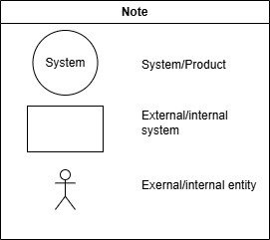
Figure 1. System Context Diagram Legend

No. | Element | Notation | Description
1 | System / Product | Rectangle | The main system or product being analyzed. Serves as the central component where data interactions are focused.
2 | External/Internal System | Rectangle | Represents external or internal systems that interact with the main system
3 | External/Internal Entity | Actor (Stick Figure) | Represents users or roles interacting with the system
Table 1. System Context Diagram Legend

3.2 Use Case Diagram
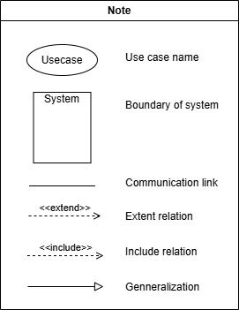
Figure 2. Use Case Diagram Legend
No. | Element | Notation | Description
1 | Actor | Stick figure | Any user or external system that interacts with the system. Actors can be primary (initiating) or secondary (participating).
2 | Use Case | Oval shape | Describes a functionality or service provided by the system to achieve an actor’s goal. Represents a unit of meaningful work.
3 | Association | Solid line connecting actors to use cases | Indicates that the actor is involved in the execution of the use case.
4 | Include Relationship | Dashed arrow labeled «include», pointing to the included use case | Specifies that the behavior of the included use case is always executed as part of the base use case.
5 | Extend Relationship | Dashed arrow labeled «extend», pointing to the extended use case | Defines optional or conditional behavior that may extend the functionality of the base use case.
6 | Generalization (Actor Inheritance) | Solid line with hollow triangle arrowhead pointing from specialized actor to general actor | Shows that one actor is a specialization of another, inheriting its interactions with use cases.
7 | Note | Rectangle with a folded corner or labeled "Note" | Used to provide additional explanations or annotations in the diagram.
Table 2. Use Case Diagram Legend

3.3 Screen Flow
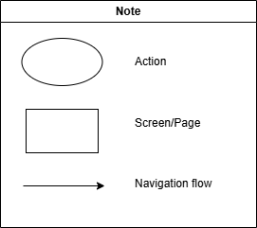
Figure 3. Screen Flow Legend

No. | Element | Notation | Description
1 | Screen / Page | Rectangle | Represents a user interface screen or page.
2 | Navigation Flow | Solid Arrow (→) | Indicates a transition between screens via navigation or button.
3 | External/Internal Entity | Ellipse / Oval | Represents an operation triggered by the user or system, such as a popup or feedback action

Table 3. Screen Flow Legend

3.4 Entity Relationship Diagram
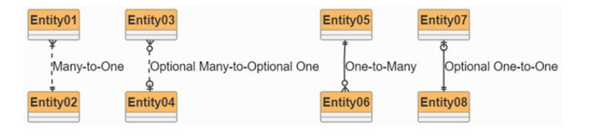
Figure 4. Entity Relationship Diagram Legend

No. | Element | Notation | Description
1 | Many-to-One | Many records in the child entity relate to one record in the parent entity. | Crow's foot at the "many" side, single line at the "one" side.
2 | Optional Many-to-Optional One | A record may or may not exist on both sides of the relationship. | A record may or may not exist on both sides of the relationship.
3 | One-to-Many | One record in the parent relates to many records in the child entity. | Single line at the "one" side, crow's foot at the "many" side.
4 | Optional One-to-One | A record may optionally relate to one other record. | Single line with hollow circles at both ends indicating optionality.
Table 4. Entity Relationship Diagram Legend

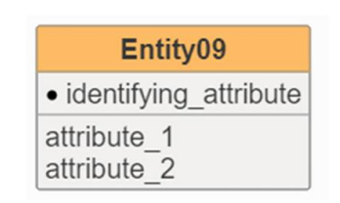
Figure 5. Entity Relationship Table Legend

No. | Element | Description
1 | Entity / Table | Represented as a rectangle with the entity name at the top and a list of attributes below.
2 | Primary Key (PK) | The identifying attribute of an entity, uniquely distinguishing each record in the table.
3 | Attribute | A field or column in the entity that stores data. Non-primary key attributes are listed below the primary key.
4 | Relationships | Define how entities are connected and how data is shared between them. Includes cardinality and optionality.
Table 5. Entity Relationship Table Legend

3.5 Main Workflows
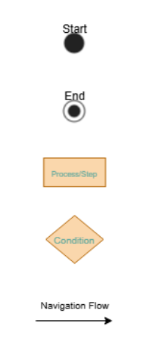
Figure 6. Main Workflows Legend

No. | Element | Notation | Description
1 | Process / Step | Rectangle | Represents a step or activity in the workflow
2 | Condition | Diamond | Indicates a decision point where the flow can branch based on a condition.
3 | Navigation Flow | Solid Arrow (→) | Shows the direction of activity or data flow between steps.
4 | Start | Circle(White) | Indicates the entry point of the workflow.
5 | End | Circle (Black filled) | Indicates the end of the workflow.
Table 6. Main workflows Legend

Project Specification

1. Project Introduction

1.1. Project Name
PrintHub - Multi-Vendor Printing & Fabrication Service Marketplace

1.2. Objectives
PrintHub is a web-based marketplace that connects customers who need printing and fabrication services with independent print shops in their area. Instead of sending files through chat applications and waiting for a manually calculated price, a customer configures an order once and immediately receives comparable quotes from multiple nearby shops - price, estimated completion time, and rating - then chooses a shop, orders, and tracks the job to completion.
The project demonstrates the required PRN232 technical outcomes: a multi-layer architecture, RESTful APIs, Entity Framework Core with Microsoft SQL Server, JWT authentication with role-based and shop-scoped authorization, OData, JSON/XML/CSV content negotiation, a client application, and service-to-service communication through a gRPC Quote Engine and an asynchronous production pipeline over RabbitMQ.

1.3. Scope
In scope:
• Account management with Customer, Shop Owner, Shop Staff, and Admin roles. Customers self-register; shops are created through an application reviewed by an Admin.
• Shop discovery: search, filter, sort, and paginate shops and view rate cards and reviews.
• Shop management: storefront profile, rate card (services + pricing rules), machines, materials, and staff.
• Multi-shop quote comparison computed by a gRPC Quote Engine using each shop's pricing rules.
• Order lifecycle: place (wallet payment), shop accept/decline, asynchronous production, hand-over, cancel.
• Internal wallet with VietQR top-up, payment, and automatic refunds.
• Reviews after completion and a complaint / resolution workflow.
• Revenue, commission, and platform reports; OData query endpoints.
Out of scope:
• A live banking API - top-up is confirmed against the platform record (a valid VietQR code is still generated).
• Shop payout/settlement transfers (commission is calculated and reported only).
• Real courier/logistics integration and automated order dispatch (the customer selects the shop).
• Physical printer/machine drivers - production is executed by a software agent that simulates machine behaviour.
• Automated content inspection of uploaded files (rights are declared by the customer).

1.4. System Context Diagram

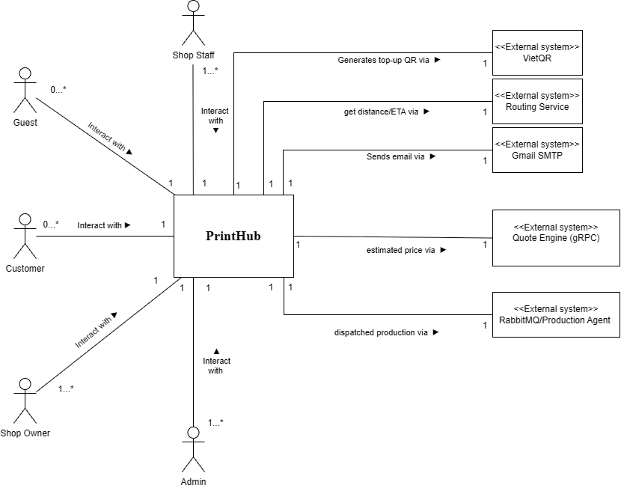

External Entity | Input to System (Data flow) | Output from System (Data flow)
Guest | Shop search criteria, shop detail request, registration information | Shop directory, shop rate cards, reviews, public statistics
Customer | Login credentials, uploaded files, order item configuration, quote comparison request, order confirmation, cancellation request, wallet top-up request, review, complaint | Authentication token, comparative quote list, order confirmation, order status updates, wallet balance and statement, VietQR payload, notifications
Shop Owner | Shop application, storefront profile updates, rate card and pricing rules, machine registry, material stock, staff assignment, complaint response | Application review result, shop order statistics, revenue and commission report, low-stock alerts, complaint records
Shop Staff | Order acceptance or decline with reason, production start, production result, hand-over confirmation | Incoming order queue, order specifications and attached files, machine status, production progress events
Administrator | Shop application decision, suspension action, user account action, service catalogue and commission configuration, voucher definition, complaint adjudication, report parameters | Pending application list, platform statistics, transaction and commission reports, complaint records, audit log
Quote Engine (gRPC) | Computed price breakdown, estimated completion minutes, applicable pricing rule trace | Order item specifications, shop pricing rules, machine availability, service type definitions
Production Agent (MQ) | Production progress percentage, completion event, failure event with reason | Production job message containing order identifier, item specifications, and assigned machine
VietQR | - | Bank account identifier, amount, reference code (encoded into QR payload)
Routing Service | Distance in metres, estimated travel duration | Customer coordinates, shop coordinates
Gmail SMTP | Delivery status | Transactional emails: account verification, password reset, order status change, complaint update

2. User Roles
Role | Description | Main permissions
Guest | Unauthenticated visitor | Browse the shop directory, view rate cards and reviews (no ordering)
Customer | Person ordering services | Register/login, maintain a document library, compare quotes, order and pay from a wallet, track and collect orders, review and complain, apply to open a shop
Shop Owner | Proprietor of a shop | Manage own shop: profile, rate card and pricing rules, machines, materials, staff; view revenue reports
Shop Staff | Counter operator of a shop | Process the shop's order queue and manage machines/materials; cannot change pricing or view full revenue
Admin | Platform operator | Review/suspend shops, manage users, maintain the service catalogue and commission, adjudicate complaints, view platform reports
Shop operations are scoped by membership: an owner or staff member may act only on a shop they belong to (verified from the JWT's shop claims). This second authorization dimension - not just "what role" but "which shop" - is enforced in the service layer.

3. Use Cases

3.1. Use Case List
ID | Use Case | Feature | Actor | Description
UC-01 | Register Account | Authentication | Guest | Allows a guest to create a new account using full name, email, phone number, and password.
UC-02 | Log In | Authentication | Guest | Allows a registered user to authenticate and receive an access token and refresh token.
UC-03 | Forgot Password | Authentication | Guest | Allows a user to reset a forgotten password via a verification link sent to their registered email.
UC-04 | Log Out | Profile Management | Common User | Allows an authenticated user to terminate their session and revoke the refresh token server-side.
UC-05 | Change Password | Profile Management | Common User | Allows a user to update their password after verifying the current one.
UC-06 | View Personal Profile | Profile Management | Common User | Allows a user to view their own account information.
UC-07 | Update Personal Profile | Profile Management | Common User | Allows a user to edit their display name, phone number, and default address.
UC-08 | View Notifications | Notification | Common User | Allows a user to view system notifications relating to their orders, complaints, and account.
UC-09 | Browse & Search Shops | Shop Discovery | Guest, Customer | Allows a visitor to browse the shop directory with filtering, sorting, and pagination by service group, area, rating, and price.
UC-10 | View Shop Detail | Shop Discovery | Guest, Customer | Allows a visitor to view a shop’s profile, published rate card, machine list, and customer reviews.
UC-11 | Manage Favourite Shops | Shop Discovery | Customer | Allows a customer to add or remove shops from a personal favourites list and view that list.
UC-12 | Manage Document Library | Order Preparation | Customer | Allows a customer to upload, view, rename, and delete files in their personal document library.
UC-13 | Configure Order & Compare Quotes | Quoting | Customer | Allows a customer to configure order items against service types and receive comparable quotes from all eligible shops.
UC-14 | Apply Voucher | Quoting | Customer | Allows a customer to apply a promotional voucher code to a quoted order and see the recalculated total.
UC-15 | Place Order | Ordering | Customer | Allows a customer to confirm a selected quote, choose fulfilment method and pickup slot, and pay from the wallet.
UC-16 | Track Order Status | Ordering | Customer | Allows a customer to view the current status, progress, and full transition history of their order.
UC-17 | Cancel Order | Ordering | Customer | Allows a customer to cancel an order before production begins, with a refund computed by the cancellation rule.
UC-18 | Reorder Previous Order | Ordering | Customer | Allows a customer to create a new order pre-populated from a previous completed order.
UC-19 | Confirm Order Receipt | Ordering | Customer | Allows a customer to confirm collection of a completed order, moving it to Completed.
UC-20 | View Order History | Ordering | Customer | Allows a customer to browse, filter, and search their own past orders.
UC-21 | Top Up Wallet | Wallet | Customer | Allows a customer to request a wallet top-up and receive a VietQR payload with a unique reference code.
UC-22 | View Wallet Statement | Wallet | Customer | Allows a customer to view their balance and a filterable ledger of all wallet transactions.
UC-23 | Submit Shop Review | Review & Complaint | Customer | Allows a customer who has completed an order to rate and review the fulfilling shop.
UC-24 | Raise Order Complaint | Review & Complaint | Customer | Allows a customer to raise a complaint against a completed order and respond to the shop’s proposed resolution.
UC-25 | Apply to Open Shop | Shop Onboarding | Customer | Allows a customer to submit an application to operate a shop on the platform.
UC-26 | Manage Shop Profile | Shop Management | Shop Owner | Allows an owner to maintain the shop storefront profile, address, contact details, and operating hours.
UC-27 | Manage Service & Pricing | Shop Management | Shop Owner | Allows an owner to publish and maintain the shop’s rate card: offered service types, unit prices, pricing rules, lead times, and minimum quantities.
UC-28 | Manage Machines & Materials | Shop Management | Shop Owner, Shop Staff | Allows shop personnel to maintain the machine registry and material stock levels, and to set machine status.
UC-29 | Manage Shop Staff | Shop Management | Shop Owner | Allows an owner to grant, revoke, and list operational access for staff members of their shop.
UC-30 | View Shop Revenue Report | Shop Reporting | Shop Owner | Allows an owner to view revenue, commission, service mix, and machine utilisation reports for their own shop.
UC-31 | View Order Queue | Shop Operations | Shop Staff, Shop Owner | Allows shop personnel to view incoming and in-progress orders for their shop, filtered by status and priority.
UC-32 | Accept or Decline Order | Shop Operations | Shop Staff, Shop Owner | Allows shop personnel to accept an incoming order or decline it with a recorded reason, triggering an automatic refund.
UC-33 | Execute Production | Shop Operations | Shop Staff, Shop Owner | Allows shop personnel to assign a machine and start production, and to monitor progress reported by the Production Agent.
UC-34 | Hand Over Order | Shop Operations | Shop Staff, Shop Owner | Allows shop personnel to record hand-over of a completed order to the customer at the counter.
UC-35 | Respond to Complaint | Shop Operations | Shop Owner, Shop Staff | Allows shop personnel to respond to a customer complaint with a reprint or refund resolution.
UC-36 | Review Shop Application | Platform Administration | Admin | Allows an administrator to review a pending shop application and approve or reject it with a recorded reason.
UC-37 | Suspend or Reinstate Shop | Platform Administration | Admin | Allows an administrator to suspend an active shop for policy violation and later reinstate it.
UC-38 | Manage User Accounts | Platform Administration | Admin | Allows an administrator to view, search, lock, and unlock platform user accounts.
UC-39 | Manage Service Catalog & Commission | Platform Administration | Admin | Allows an administrator to maintain the platform-wide service type catalogue and configure the commission rate.
UC-40 | Manage Vouchers | Platform Administration | Admin | Allows an administrator to create, edit, deactivate, and monitor usage of promotional vouchers.
UC-41 | Adjudicate Escalated Complaint | Platform Administration | Admin | Allows an administrator to make a final ruling on a complaint escalated beyond the shop.
UC-42 | View & Export Platform Reports | Platform Reporting | Admin | Allows an administrator to view platform-wide reports and export them as JSON, XML, or CSV.

3.2. Use Case Diagram
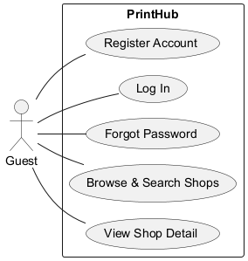
Usecase for Guest

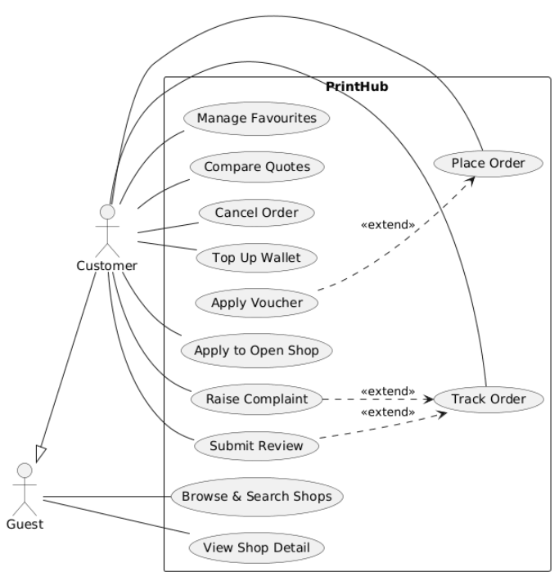
Usecase for Customer

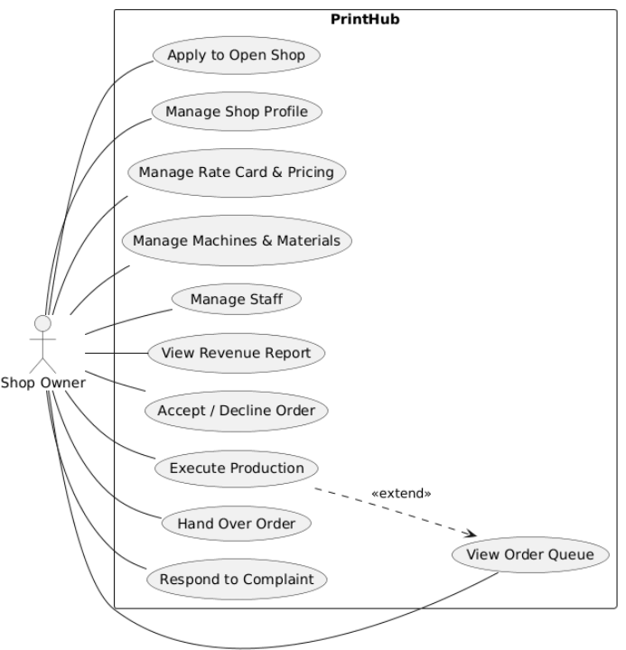
Usecase for Shop Owner

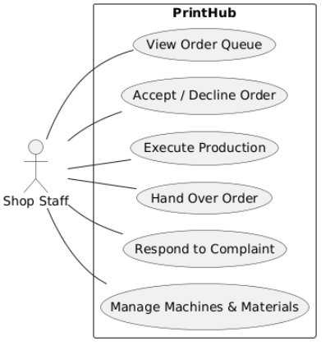
Usecase for Shop Staff

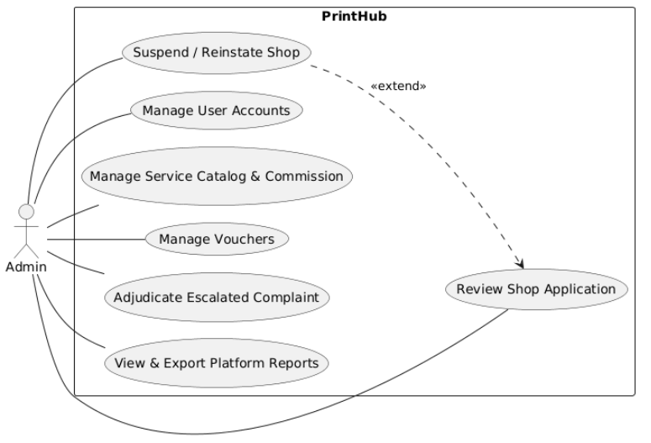
Usecase for Admin

4. ERD and Database Schema

4.1. Main Entities
Entity | Purpose
User | Authentication account, role, wallet balance, and profile
RefreshToken | Server-side refresh token for rotation and revocation
Shop | Shop storefront, address, status (onboarding state machine), and rating
ShopStaff | User×Shop membership with attributes (position) - scoped authorization
ServiceType | Platform service catalogue; pricing model selects the pricing strategy
ShopService | Shop×ServiceType rate card with attributes (unit price, lead time) - read on every quote
PriceRule | Option multiplier / surcharge / quantity tier on a rate card entry
Machine / Material | Shop production resources and stock
DocumentFile | A customer's uploaded file (library)
Quote | A computed price for a configuration at a shop, with expiry and breakdown
Order / OrderItem | The central transaction and its configured lines
OrderStatusHistory | Append-only transition log (actor, timestamp, reason)
WalletTransaction | Wallet ledger: top-up, payment, refund, adjustment
Voucher / Review / Complaint | Promotions, ratings, and the dispute workflow
Favourite / Notification / AuditLog | Saved shops, in-app notifications, administrative audit trail
The schema has one-to-many relationships throughout and three many-to-many relationships carrying their own attributes: ShopService (the rate card), ShopStaff (memberships), and Favourite. All 21 tables are generated code-first from the entities and Fluent API configuration.

4.2. Entity Relationship Diagram
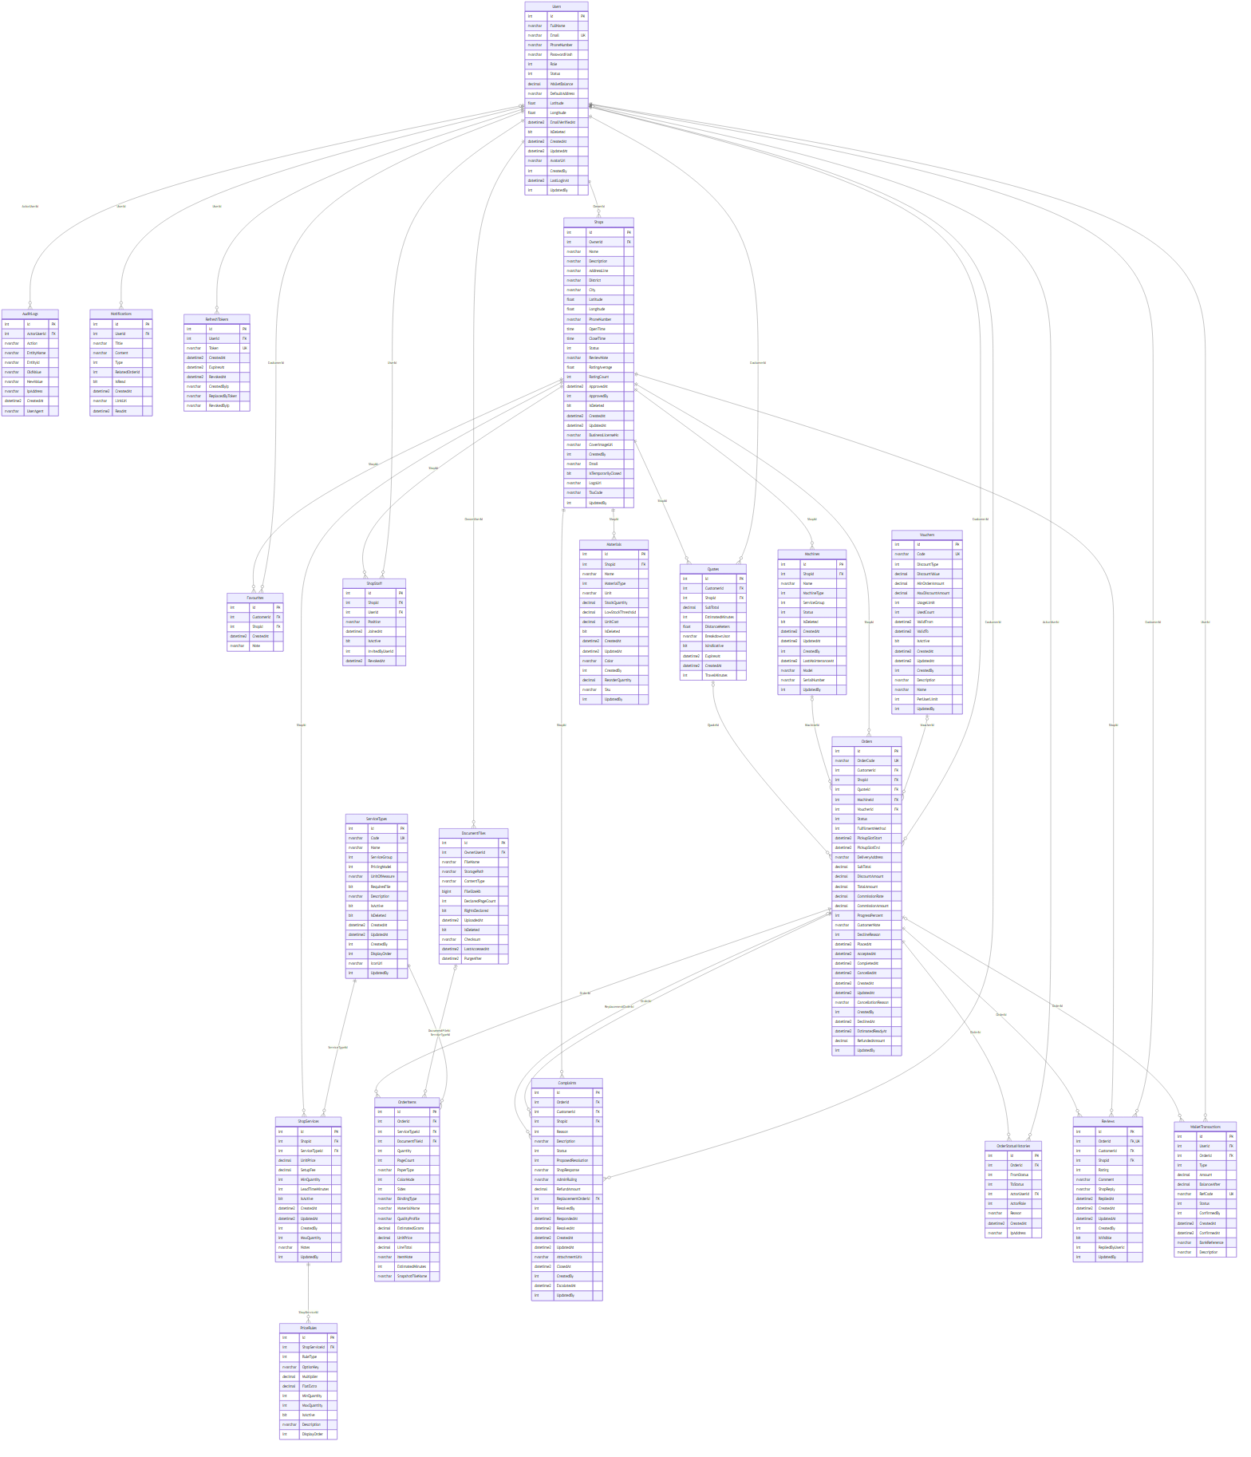
Entity Relationship Diagram Detail

4.3. Important Database Constraints
• User.Email, ServiceType.Code, Voucher.Code, Order.OrderCode, and WalletTransaction.RefCode are unique.
• ShopService(ShopId, ServiceTypeId), ShopStaff(ShopId, UserId), and Favourite(CustomerId, ShopId) have composite unique indexes.
• Review.OrderId is unique - one review per order.
• Delete behaviours are chosen to avoid multiple cascade paths on SQL Server; most references use Restrict.
• Soft delete on User/Shop/ServiceType/Machine/Material/DocumentFile via a global query filter preserves history.
• Monetary values use decimal(18,2); timestamps are stored in UTC.
• CreatedAt/UpdatedAt are stamped centrally by the DbContext, not by callers.

4.4. Data Dictionary
Every field of each table, generated from the live database schema (types shown as SQL types; PK/FK/UK marked). Common audit columns CreatedAt/UpdatedAt/CreatedBy/UpdatedBy appear on entities derived from the auditable base.
AuditLogs — Administrative audit trail.
Field | Type | Key
Id | int | PK
ActorUserId | int | FK
Action | nvarchar
EntityName | nvarchar
EntityId | nvarchar
OldValue | nvarchar
NewValue | nvarchar
IpAddress | nvarchar
CreatedAt | datetime2
UserAgent | nvarchar
Complaints — Dispute/resolution records.
Field | Type | Key
Id | int | PK
OrderId | int | FK
CustomerId | int | FK
ShopId | int | FK
Reason | int
Description | nvarchar
Status | int
ProposedResolution | int
ShopResponse | nvarchar
AdminRuling | nvarchar
RefundAmount | decimal
ReplacementOrderId | int | FK
ResolvedBy | int
RespondedAt | datetime2
ResolvedAt | datetime2
CreatedAt | datetime2
UpdatedAt | datetime2
AttachmentUrls | nvarchar
ClosedAt | datetime2
CreatedBy | int
EscalatedAt | datetime2
UpdatedBy | int
DocumentFiles — Customer document library.
Field | Type | Key
Id | int | PK
OwnerUserId | int | FK
FileName | nvarchar
StoragePath | nvarchar
ContentType | nvarchar
FileSizeKb | bigint
DeclaredPageCount | int
RightsDeclared | bit
UploadedAt | datetime2
IsDeleted | bit
Checksum | nvarchar
LastAccessedAt | datetime2
PurgeAfter | datetime2
Favourites — Saved shops.
Field | Type | Key
Id | int | PK
CustomerId | int | FK
ShopId | int | FK
CreatedAt | datetime2
Note | nvarchar
Machines — Shop production machines.
Field | Type | Key
Id | int | PK
ShopId | int | FK
Name | nvarchar
MachineType | int
ServiceGroup | int
Status | int
IsDeleted | bit
CreatedAt | datetime2
UpdatedAt | datetime2
CreatedBy | int
LastMaintenanceAt | datetime2
Model | nvarchar
SerialNumber | nvarchar
UpdatedBy | int
Materials — Shop material stock.
Field | Type | Key
Id | int | PK
ShopId | int | FK
Name | nvarchar
MaterialType | int
Unit | nvarchar
StockQuantity | decimal
LowStockThreshold | decimal
UnitCost | decimal
IsDeleted | bit
CreatedAt | datetime2
UpdatedAt | datetime2
Color | nvarchar
CreatedBy | int
ReorderQuantity | decimal
Sku | nvarchar
UpdatedBy | int
Notifications — In-app notifications.
Field | Type | Key
Id | int | PK
UserId | int | FK
Title | nvarchar
Content | nvarchar
Type | int
RelatedOrderId | int
IsRead | bit
CreatedAt | datetime2
LinkUrl | nvarchar
ReadAt | datetime2
OrderItems — Configured order lines.
Field | Type | Key
Id | int | PK
OrderId | int | FK
ServiceTypeId | int | FK
DocumentFileId | int | FK
Quantity | int
PageCount | int
PaperType | nvarchar
ColorMode | int
Sides | int
BindingType | nvarchar
MaterialName | nvarchar
QualityProfile | nvarchar
EstimatedGrams | decimal
UnitPrice | decimal
LineTotal | decimal
ItemNote | nvarchar
EstimatedMinutes | int
SnapshotFileName | nvarchar
OrderStatusHistories — Append-only order transition log.
Field | Type | Key
Id | int | PK
OrderId | int | FK
FromStatus | int
ToStatus | int
ActorUserId | int | FK
ActorRole | int
Reason | nvarchar
CreatedAt | datetime2
IpAddress | nvarchar
Orders — The central transaction aggregate.
Field | Type | Key
Id | int | PK
OrderCode | nvarchar | UK
CustomerId | int | FK
ShopId | int | FK
QuoteId | int | FK
MachineId | int | FK
VoucherId | int | FK
Status | int
FulfilmentMethod | int
PickupSlotStart | datetime2
PickupSlotEnd | datetime2
DeliveryAddress | nvarchar
SubTotal | decimal
DiscountAmount | decimal
TotalAmount | decimal
CommissionRate | decimal
CommissionAmount | decimal
ProgressPercent | int
CustomerNote | nvarchar
DeclineReason | int
PlacedAt | datetime2
AcceptedAt | datetime2
CompletedAt | datetime2
CancelledAt | datetime2
CreatedAt | datetime2
UpdatedAt | datetime2
CancellationReason | nvarchar
CreatedBy | int
DeclinedAt | datetime2
EstimatedReadyAt | datetime2
RefundedAmount | decimal
UpdatedBy | int
PriceRules — Pricing rules on a rate card entry.
Field | Type | Key
Id | int | PK
ShopServiceId | int | FK
RuleType | int
OptionKey | nvarchar
Multiplier | decimal
FlatExtra | decimal
MinQuantity | int
MaxQuantity | int
IsActive | bit
Description | nvarchar
DisplayOrder | int
Quotes — Computed quotes per shop (with expiry).
Field | Type | Key
Id | int | PK
CustomerId | int | FK
ShopId | int | FK
SubTotal | decimal
EstimatedMinutes | int
DistanceMeters | float
BreakdownJson | nvarchar
IsIndicative | bit
ExpiresAt | datetime2
CreatedAt | datetime2
TravelMinutes | int
RefreshTokens — Server-side refresh tokens for rotation/revocation.
Field | Type | Key
Id | int | PK
UserId | int | FK
Token | nvarchar | UK
CreatedAt | datetime2
ExpiresAt | datetime2
RevokedAt | datetime2
CreatedByIp | nvarchar
ReplacedByToken | nvarchar
RevokedByIp | nvarchar
Reviews — Shop reviews (one per order).
Field | Type | Key
Id | int | PK
OrderId | int | FK,UK
CustomerId | int | FK
ShopId | int | FK
Rating | int
Comment | nvarchar
ShopReply | nvarchar
RepliedAt | datetime2
CreatedAt | datetime2
UpdatedAt | datetime2
CreatedBy | int
IsVisible | bit
RepliedByUserId | int
UpdatedBy | int
ServiceTypes — Platform service catalogue.
Field | Type | Key
Id | int | PK
Code | nvarchar | UK
Name | nvarchar
ServiceGroup | int
PricingModel | int
UnitOfMeasure | nvarchar
RequiresFile | bit
Description | nvarchar
IsActive | bit
IsDeleted | bit
CreatedAt | datetime2
UpdatedAt | datetime2
CreatedBy | int
DisplayOrder | int
IconUrl | nvarchar
UpdatedBy | int
ShopServices — Shop rate card (Shop×ServiceType with pricing).
Field | Type | Key
Id | int | PK
ShopId | int | FK
ServiceTypeId | int | FK
UnitPrice | decimal
SetupFee | decimal
MinQuantity | int
LeadTimeMinutes | int
IsActive | bit
CreatedAt | datetime2
UpdatedAt | datetime2
CreatedBy | int
MaxQuantity | int
Notes | nvarchar
UpdatedBy | int
ShopStaff — User×Shop membership (scoped authorization).
Field | Type | Key
Id | int | PK
ShopId | int | FK
UserId | int | FK
Position | nvarchar
JoinedAt | datetime2
IsActive | bit
InvitedByUserId | int
RevokedAt | datetime2
Shops — Shop storefronts and onboarding status.
Field | Type | Key
Id | int | PK
OwnerId | int | FK
Name | nvarchar
Description | nvarchar
AddressLine | nvarchar
District | nvarchar
City | nvarchar
Latitude | float
Longitude | float
PhoneNumber | nvarchar
OpenTime | time
CloseTime | time
Status | int
ReviewNote | nvarchar
RatingAverage | float
RatingCount | int
ApprovedAt | datetime2
ApprovedBy | int
IsDeleted | bit
CreatedAt | datetime2
UpdatedAt | datetime2
BusinessLicenseNo | nvarchar
CoverImageUrl | nvarchar
CreatedBy | int
Email | nvarchar
IsTemporarilyClosed | bit
LogoUrl | nvarchar
TaxCode | nvarchar
UpdatedBy | int
Users — Platform accounts (role, wallet, profile).
Field | Type | Key
Id | int | PK
FullName | nvarchar
Email | nvarchar | UK
PhoneNumber | nvarchar
PasswordHash | nvarchar
Role | int
Status | int
WalletBalance | decimal
DefaultAddress | nvarchar
Latitude | float
Longitude | float
EmailVerifiedAt | datetime2
IsDeleted | bit
CreatedAt | datetime2
UpdatedAt | datetime2
AvatarUrl | nvarchar
CreatedBy | int
LastLoginAt | datetime2
UpdatedBy | int
Vouchers — Promotional vouchers.
Field | Type | Key
Id | int | PK
Code | nvarchar | UK
DiscountType | int
DiscountValue | decimal
MinOrderAmount | decimal
MaxDiscountAmount | decimal
UsageLimit | int
UsedCount | int
ValidFrom | datetime2
ValidTo | datetime2
IsActive | bit
CreatedAt | datetime2
UpdatedAt | datetime2
CreatedBy | int
Description | nvarchar
Name | nvarchar
PerUserLimit | int
UpdatedBy | int
WalletTransactions — Wallet ledger.
Field | Type | Key
Id | int | PK
UserId | int | FK
OrderId | int | FK
Type | int
Amount | decimal
BalanceAfter | decimal
RefCode | nvarchar | UK
Status | int
ConfirmedBy | int
CreatedAt | datetime2
ConfirmedAt | datetime2
BankReference | nvarchar
Description | nvarchar

5. Business Rules
ID | Rule
BR-01 | One account per email. New accounts are Customers with a zero wallet balance; passwords are BCrypt-hashed.
BR-02 | Login returns a single generic error so account existence cannot be probed; locked accounts are not issued a token.
BR-03 | A refresh token is revoked server-side on logout; a password change revokes every active refresh token.
BR-04 | A user may act only on their own records; identity comes from the token, never a client-supplied id.
BR-05 | Owner/staff may act only on a shop they belong to (scoped authorization); cross-shop access returns 403.
BR-06 | Only an Admin approves a shop; approval elevates the applicant to Shop Owner. Shop transitions follow the onboarding state machine.
BR-07 | Only the Shop Owner manages pricing; staff cannot view or change the rate card or revenue.
BR-08 | Rate card prices are non-negative and multipliers positive; quantity tiers on one entry must not overlap.
BR-09 | A machine producing an order cannot be taken offline; material stock cannot be negative.
BR-10 | A quote is computed only for eligible shops (offers every service and has a non-offline machine per group) and expires after 24 hours.
BR-11 | When the Quote Engine is unavailable the platform returns an indicative price and marks it as non-final (graceful degradation).
BR-12 | An order is placed only against a valid, unexpired quote with a sufficient wallet balance; placement debits the wallet and snapshots the quote atomically.
BR-13 | Order status changes follow the order state machine; every transition is recorded in an append-only history with actor and reason.
BR-14 | Declining an order refunds the customer in full; cancellation before production refunds per the cancellation rule.
BR-15 | Production runs asynchronously through a message queue and never inside an HTTP request; event handling is idempotent.
BR-16 | Only a customer who owns a completed order may review it, once; only a completed order may raise a complaint within a window.
BR-17 | Every wallet transaction records the resulting balance so the ledger is independently verifiable; balances are never edited directly.
BR-18 | Administrative actions (approve/suspend/lock/adjudicate) require a reason and are written to the audit log.

6. Workflows

6.1. Order Workflow
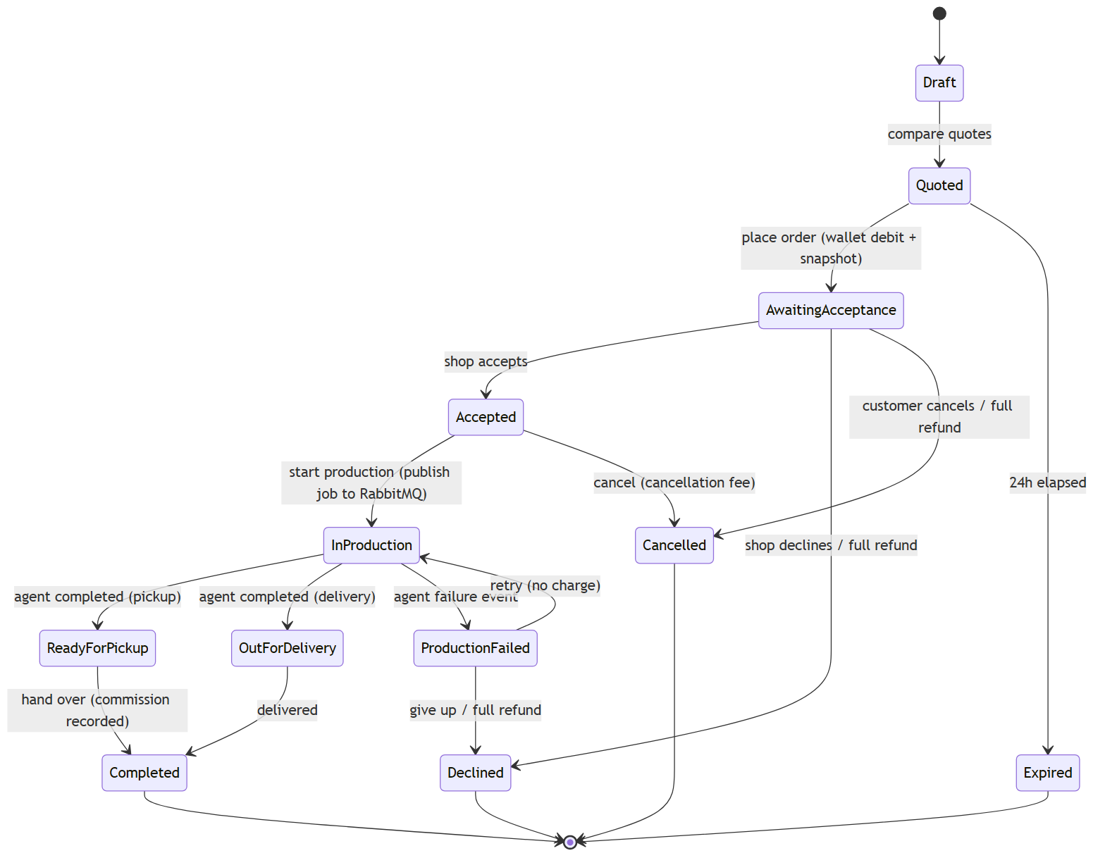

Status | Meaning | Valid next status
Draft / Quoted | Configured; comparable quotes generated | AwaitingAcceptance, Expired
AwaitingAcceptance | Placed and paid; awaiting the shop | Accepted, Declined, Cancelled
Accepted | Shop committed capacity | InProduction, Cancelled (with fee)
InProduction | Production job dispatched to the agent | ReadyForPickup, OutForDelivery, ProductionFailed
ProductionFailed | Machine fault reported by the agent | InProduction (retry), Declined (refund)
ReadyForPickup / OutForDelivery | Production complete | Completed
Completed | Handed over; commission recorded | Terminal (complaint may follow)
Declined / Cancelled | Refunded per rule | Terminal
Production is asynchronous: on start, the API publishes a job message to RabbitMQ; a Production Agent consumes it, simulates the machine, and publishes progress/completion/failure events that the API applies to the order. A dead-letter queue and idempotent handlers make the pipeline safe under redelivery and failure.

6.2. Shop Onboarding Workflow
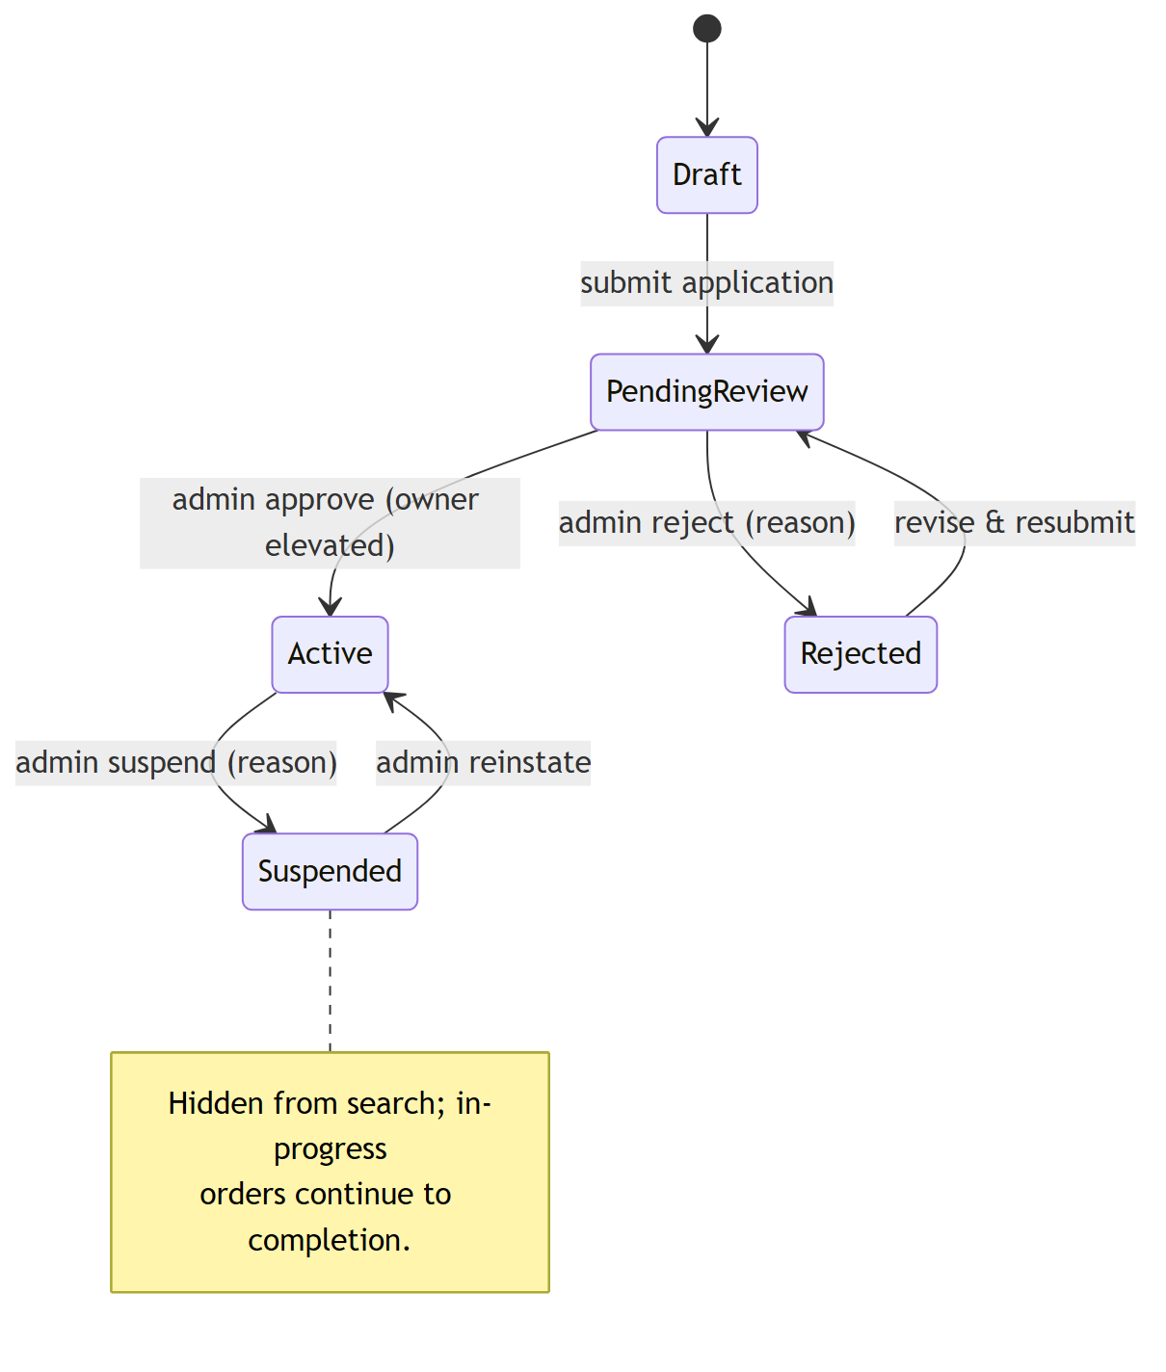

Status | Meaning | Valid next status
Draft / PendingReview | Application submitted, awaiting Admin review | Active, Rejected
Active | Approved; discoverable and accepting orders | Suspended
Rejected | Declined with a reason; may be revised | PendingReview
Suspended | Removed from discovery; in-progress orders continue | Active (reinstate)

6.3. Complaint / Resolution Workflow
Status | Meaning | Valid next status
Open | Customer raised a complaint on a completed order | ShopResponded, Escalated
ShopResponded | Shop proposed a reprint or refund | Resolved, Escalated
Escalated | Customer rejected, or the shop did not respond in time | Closed
Resolved | Customer accepted the resolution | Terminal
Closed | Administrator adjudicated (final ruling) | Terminal
A complaint escalates automatically when the shop does not respond within the window; the administrator's ruling is final within the system.

7. System Architecture

7.1. Architecture Diagram
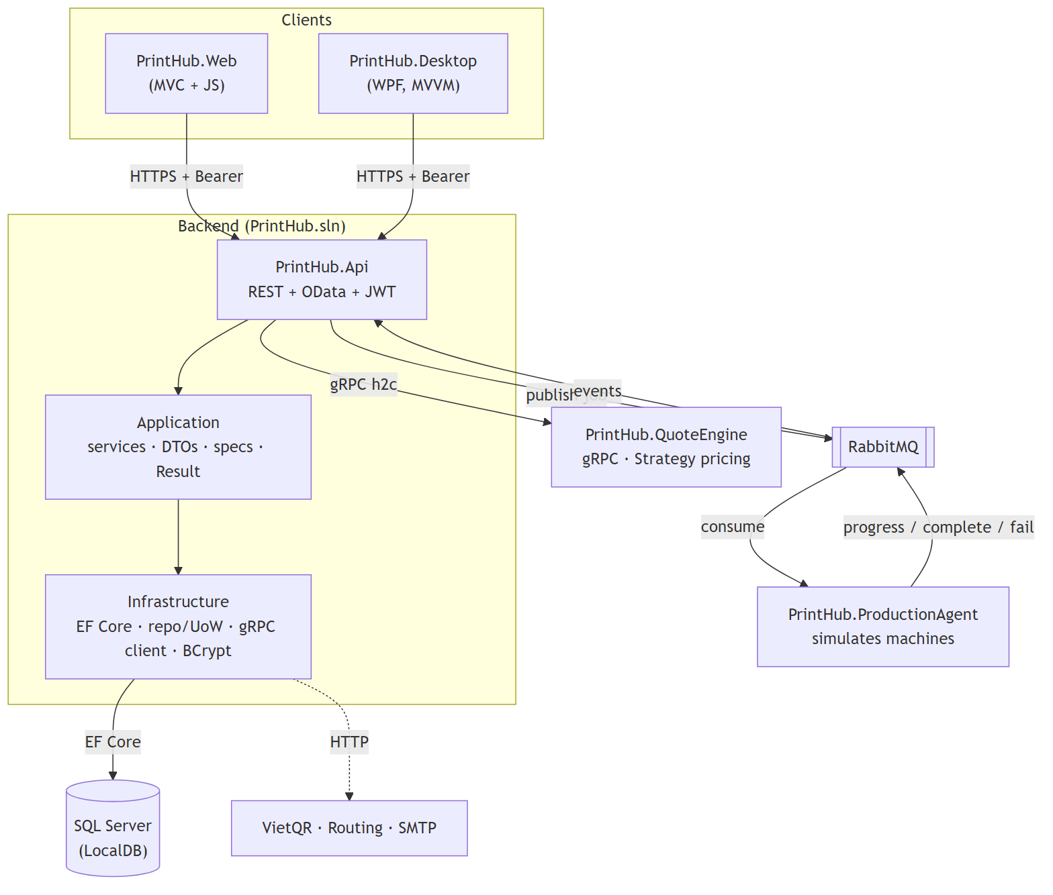

7.2. Layer Responsibilities
Layer / Project | Responsibility
PrintHub.Api | Controllers, OData, JWT auth, content negotiation, validation filter, global exception middleware, response wrapper
PrintHub.Application | Use-case services (Result pattern), DTOs, AutoMapper, FluentValidation, specifications, repository/UoW interfaces
PrintHub.Domain | Entities, enums, and base types (auditing, soft delete) - depends on nothing
PrintHub.Infrastructure | DbContext + EF configuration + migrations, repository/UoW/specification evaluator, BCrypt, JWT, gRPC client
PrintHub.Contracts | Shared gRPC proto and message contracts
PrintHub.QuoteEngine | gRPC pricing service (Strategy per pricing model)
PrintHub.ProductionAgent | Worker consuming RabbitMQ; simulates machines and publishes progress
PrintHub.Web / PrintHub.Desktop | ASP.NET Core MVC + JavaScript customer client; WPF (MVVM) shop/admin client
Controllers stay thin: they receive a request, call a service, and map the Result to an HTTP status. Business rules, workflow validation, ownership checks, and transactions live in the service layer. Queries flow through specifications, keeping repositories thin.

8. Service Design
Service | Responsibility
AuthService | Register, login, refresh (rotating), logout, change password; issues JWTs with shop claims
ShopCatalogService | Public shop search and detail via specifications
FavouriteService | Add/remove/list a customer's favourite shops
ShopOnboardingService / ShopAdminService | Apply to open a shop; admin approve/reject/suspend/reinstate (state machine + audit)
ShopProfileService / RateCardService | Owner storefront profile; rate card (ShopService + PriceRule) with tier validation
ShopStaffService / ShopResourceService | Staff grant/revoke; machines and materials (owner or staff)
QuoteService | Eligibility, fan-out to the gRPC Quote Engine, persist quotes, rank, indicative fallback
OrderService / WalletService | Order state machine, atomic placement + wallet debit, refunds, commission
ReviewService / ComplaintService | Reviews and the complaint/resolution workflow
ReportService | Revenue, commission, service mix, and platform statistics
NotificationService / AuditLogService | In-app notifications from events; append-only audit of admin actions

9. API Endpoint List
Convention: Guest endpoints need no token; others need a JWT. Shop endpoints are membership-scoped; admin endpoints require the Admin role. Status: implemented vs designed.

9.1 Authentication & Profile
Method | Route | Access | UC | Description | Status
POST | /api/auth/register | Guest | UC-01 | Register a Customer account | ✔
POST | /api/auth/login | Guest | UC-02 | Authenticate → JWT + refresh token | ✔
POST | /api/auth/refresh | Guest | UC-02 | Rotate access token from refresh token | ✔
POST | /api/auth/forgot-password | Guest | UC-03 | Request a password-reset link | ◻
POST | /api/auth/reset-password | Guest | UC-03 | Reset password with the emailed token | ◻
POST | /api/auth/logout | Authenticated | UC-04 | Revoke the refresh token server-side | ✔
POST | /api/auth/change-password | Authenticated | UC-05 | Change password + revoke all tokens | ✔
GET | /api/auth/me | Authenticated | — | Identity/role/shop claims from the token | ✔
GET | /api/users/me | Authenticated | UC-06 | View own profile (full account info) | ◻
PUT | /api/users/me | Authenticated | UC-07 | Update display name, phone, default address | ◻

9.2 Notifications
Method | Route | Access | UC | Description | Status
GET | /api/notifications | Authenticated | UC-08 | List own notifications (paged, newest first) | ◻
PUT | /api/notifications/read | Authenticated | UC-08 | Mark displayed notifications as read | ◻

9.3 Shop Discovery & Favourites
Method | Route | Access | UC | Description | Status
GET | /api/shops | Guest | UC-09 | Search/filter/sort/paginate active shops | ✔
GET | /api/shops/{id} | Guest | UC-10 | Shop profile, rate card, machines, reviews | ✔
GET | /api/favourites | Customer | UC-11 | List favourite shops | ✔
POST | /api/favourites/{shopId} | Customer | UC-11 | Add a favourite (idempotent) | ✔
DELETE | /api/favourites/{shopId} | Customer | UC-11 | Remove a favourite | ✔

9.4 Document Library
Method | Route | Access | UC | Description | Status
GET | /api/documents | Customer | UC-12 | List own uploaded files | ◻
POST | /api/documents | Customer | UC-12 | Upload a file (type/size/rights validated) | ◻
PUT | /api/documents/{id} | Customer | UC-12 | Rename a file | ◻
DELETE | /api/documents/{id} | Customer | UC-12 | Soft-delete a file (blocked if on an active order) | ◻

9.5 Quoting
Method | Route | Access | UC | Description | Status
POST | /api/quotes/compare | Customer | UC-13 | Compare quotes across eligible shops (gRPC) | ✔
POST | /api/quotes/{id}/apply-voucher | Customer | UC-14 | Apply a voucher and recompute the total | ◻

9.6 Orders (Customer)
Method | Route | Access | UC | Description | Status
POST | /api/orders | Customer | UC-15 | Place an order from a quote (wallet payment) | ◻
GET | /api/orders | Customer | UC-20 | List/filter own order history (paged) | ◻
GET | /api/orders/{id} | Customer/shop | UC-16 | Track status, progress, and full history | ◻
PUT | /api/orders/{id}/cancel | Customer | UC-17 | Cancel before production (rule-based refund) | ◻
POST | /api/orders/{id}/reorder | Customer | UC-18 | Create a new draft from a completed order | ◻
PUT | /api/orders/{id}/confirm-receipt | Customer | UC-19 | Confirm collection → Completed | ◻

9.7 Wallet
Method | Route | Access | UC | Description | Status
POST | /api/wallet/topup | Customer | UC-21 | Request a top-up → VietQR payload + ref code | ◻
GET | /api/wallet/transactions | Customer | UC-22 | Balance + filterable transaction ledger | ◻
PUT | /api/admin/wallet/topups/{refCode}/confirm | Admin | UC-21 | Confirm a pending top-up against the record | ◻

9.8 Reviews & Complaints (Customer)
Method | Route | Access | UC | Description | Status
POST | /api/orders/{id}/review | Customer | UC-23 | Rate + review a completed order (one per order) | ◻
GET | /api/shops/{id}/reviews | Guest | UC-23 | List a shop's public reviews | ◻
POST | /api/complaints | Customer | UC-24 | Raise a complaint on a completed order | ◻
GET | /api/complaints/mine | Customer | UC-24 | List own complaints and their status | ◻
PUT | /api/complaints/{id}/accept | Customer | UC-24 | Accept the shop's proposed resolution | ◻
PUT | /api/complaints/{id}/escalate | Customer | UC-24 | Reject and escalate to the platform | ◻

9.9 Shop Onboarding & Management (Owner)
Method | Route | Access | UC | Description | Status
POST | /api/shops/apply | Customer | UC-25 | Apply to open a shop (→ PendingReview) | ✔
GET | /api/shops/mine | Authenticated | UC-25 | The applicant's own shops + status | ✔
PUT | /api/shops/{id}/profile | Owner | UC-26 | Update the storefront profile | ✔
GET | /api/shops/{id}/rate-card | Owner | UC-27 | View the rate card (entries + rules) | ✔
POST | /api/shops/{id}/rate-card | Owner | UC-27 | Add a service to the rate card | ✔
PUT | /api/shops/{id}/rate-card/{entryId} | Owner | UC-27 | Update pricing on an entry | ✔
POST | /api/shops/{id}/rate-card/{entryId}/rules | Owner | UC-27 | Add a pricing rule | ✔
DELETE | /api/shops/{id}/rate-card/{entryId}/rules/{ruleId} | Owner | UC-27 | Remove a pricing rule | ✔
GET/POST | /api/shops/{id}/machines | Owner/Staff | UC-28 | List / add machines | ✔
PUT | /api/shops/{id}/machines/{mId}/status | Owner/Staff | UC-28 | Set machine status (Idle/Maintenance/Offline) | ✔
DELETE | /api/shops/{id}/machines/{mId} | Owner/Staff | UC-28 | Soft-delete a machine | ✔
GET/POST | /api/shops/{id}/materials | Owner/Staff | UC-28 | List / add materials | ✔
PUT | /api/shops/{id}/materials/{matId}/stock | Owner/Staff | UC-28 | Adjust stock / low-stock threshold | ✔
DELETE | /api/shops/{id}/materials/{matId} | Owner/Staff | UC-28 | Soft-delete a material | ✔
GET | /api/shops/{id}/staff | Owner | UC-29 | List staff | ✔
POST | /api/shops/{id}/staff | Owner | UC-29 | Grant staff access (by email) | ✔
DELETE | /api/shops/{id}/staff/{staffId} | Owner | UC-29 | Revoke staff access (soft) | ✔
GET | /api/shops/{id}/reports/revenue | Owner | UC-30 | Revenue / commission / service-mix report | ◻

9.10 Shop Operations (Owner / Staff)
Method | Route | Access | UC | Description | Status
GET | /api/shops/{id}/orders | Owner/Staff | UC-31 | Order queue (filter by status) | ◻
PUT | /api/orders/{id}/accept | Owner/Staff | UC-32 | Accept an incoming order | ◻
PUT | /api/orders/{id}/decline | Owner/Staff | UC-32 | Decline with reason (auto full refund) | ◻
PUT | /api/orders/{id}/start | Owner/Staff | UC-33 | Assign a machine + start production (RabbitMQ) | ◻
PUT | /api/orders/{id}/handover | Owner/Staff | UC-34 | Record hand-over → Completed | ◻
PUT | /api/complaints/{id}/respond | Owner/Staff | UC-35 | Propose a reprint / refund resolution | ◻

9.11 Platform Administration (Admin)
Method | Route | Access | UC | Description | Status
GET | /api/admin/shops/applications | Admin | UC-36 | List pending shop applications | ✔
PUT | /api/admin/shops/{id}/approve | Admin | UC-36 | Approve (activate + elevate owner) | ✔
PUT | /api/admin/shops/{id}/reject | Admin | UC-36 | Reject with a mandatory reason | ✔
PUT | /api/admin/shops/{id}/suspend | Admin | UC-37 | Suspend an active shop (reason) | ✔
PUT | /api/admin/shops/{id}/reinstate | Admin | UC-37 | Reinstate a suspended shop | ✔
GET | /api/admin/users | Admin | UC-38 | Search / list users | ◻
PUT | /api/admin/users/{id}/lock | Admin | UC-38 | Lock an account (revokes tokens) | ◻
PUT | /api/admin/users/{id}/unlock | Admin | UC-38 | Unlock an account | ◻
GET/POST | /api/admin/service-types | Admin | UC-39 | List / add platform service types | ◻
PUT/DELETE | /api/admin/service-types/{id} | Admin | UC-39 | Update / deactivate a service type | ◻
PUT | /api/admin/commission | Admin | UC-39 | Configure the platform commission rate | ◻
GET/POST | /api/admin/vouchers | Admin | UC-40 | List / create vouchers | ◻
PUT/DELETE | /api/admin/vouchers/{id} | Admin | UC-40 | Edit / deactivate a voucher | ◻
GET | /api/admin/complaints | Admin | UC-41 | List escalated complaints | ◻
PUT | /api/admin/complaints/{id}/adjudicate | Admin | UC-41 | Final ruling (uphold refund / reject) | ◻
GET | /api/admin/audit-logs | Admin | — | View the audit log | ◻

9.12 Reports
Method | Route | Access | UC | Description | Status
GET | /api/shops/{id}/reports/revenue | Owner | UC-30 | Shop revenue / commission / service mix | ◻
GET | /api/reports/platform | Admin | UC-42 | Platform transaction/revenue/ranking reports | ◻
— | (all report endpoints support Accept: application/json | application/xml | text/csv) |  | UC-42 | Content negotiation | ◻

9.13 OData (query endpoints)
Method | Route | Access | UC | Options | Status
GET | /odata/Shops | Guest | UC-09 | $filter $orderby $top $skip $select $count | ✔
GET | /odata/Orders | Customer/shop | UC-20 | $filter $orderby $top $skip $select $expand | ◻

10. Security Matrix
Legend: Yes = permitted; Own = own record / own shop only; No = denied.
Function | Customer | Shop Owner | Shop Staff | Admin
Register / login / own profile | Yes | Yes | Yes | Yes
Browse shops, compare quotes | Yes | Yes | Yes | View
Place / track / cancel orders | Own | Own | No | View
Manage shop profile & rate card | No | Own shop | No | No
Manage machines / materials | No | Own shop | Own shop | No
Manage shop staff | No | Own shop | No | No
Operate order queue (accept/produce) | No | Own shop | Own shop | No
Approve / suspend shops | No | No | No | Yes
Manage users, catalogue, commission | No | No | No | Yes
Adjudicate complaints | No | No | No | Yes
View reports | No | Own shop | No | Platform
Security controls:
• Passwords are hashed with BCrypt and never stored or logged as plaintext.
• JWTs contain sub, email, role, jti, shop-membership claims, issued-at, and expiration.
• The signing key is loaded from configuration and is not committed as a real secret.
• [Authorize] role policies plus service-layer ownership/shop-scope checks protect every operation.
• Response DTOs never expose PasswordHash, storage paths, or a shop's material cost.
• A validation filter and global exception handling prevent invalid data and stack-trace leakage.

11. OData Demo
Endpoint | Query model | Supported options | Access
GET /odata/Shops | Shop | $filter, $orderby, $top, $skip, $select, $count | Public; active shops only
GET /odata/Orders | Order | $filter, $orderby, $top, $skip, $select, $expand | Customer sees own orders; shop sees own
Safe limits: MaxTop = 100. A mandatory server-side filter (active shops; owner's own orders) is applied before the client query composes, so a crafted query cannot widen the result set. Only DTO projections are exposed - never EF entities.

GET /odata/Shops?$filter=RatingAverage gt 4&$orderby=Name&$top=10&$select=Name,RatingAverage
Authorization: Bearer <token>
Accept: application/json
GET /odata/Orders?$filter=Status eq 'Completed'&$orderby=PlacedAt desc&$expand=Items($select=ServiceTypeId,Quantity)
Authorization: Bearer <token>

12. Content Negotiation Demo
The API uses the default JSON formatter and enables XML with AddXmlSerializerFormatters(); report endpoints add a custom CSV output formatter. Accept selects the response representation; Content-Type identifies the request body. Report endpoints declare [Produces("application/json","application/xml","text/csv")].

12.1. JSON
GET /api/shops/1
Accept: application/json
HTTP/1.1 200 OK
Content-Type: application/json; charset=utf-8

12.2. XML
GET /api/shops/1
Accept: application/xml
HTTP/1.1 200 OK
Content-Type: application/xml; charset=utf-8

12.3. CSV (reports)
GET /api/reports/platform?from=2026-07-01&to=2026-07-31
Accept: text/csv
HTTP/1.1 200 OK
Content-Type: text/csv; charset=utf-8

13. gRPC Quote Engine Demo

13.1. Purpose
A separate gRPC service (PrintHub.QuoteEngine) computes price and estimated completion time. It is a stateless calculator: the API gathers each shop's pricing data and asks the engine to price the order. This isolates pricing (and the Strategy pattern per pricing model - PerPage, PerUnit, MaterialAndTime) in a service that can evolve and scale independently. The call is made once per eligible shop when a customer compares quotes; if the engine is unavailable the API falls back to an indicative price and stays up.

13.2. Proposed Contract
syntax = "proto3";
option csharp_namespace = "PrintHub.Contracts.Quoting";
service QuoteEstimator {
rpc Estimate (EstimateRequest) returns (EstimateResponse);
}
message EstimateItem {
string pricing_model = 1; int32 quantity = 2; int32 page_count = 3;
double estimated_grams = 4; double unit_price = 5; double setup_fee = 6;
int32 lead_time_minutes = 7; repeated string selected_options = 8;
repeated PricingRuleInput rules = 9;
}
message EstimateResponse {
double subtotal = 1; int32 estimated_minutes = 2;
repeated LineBreakdown lines = 3;
}

13.3. Service Call Sequence
Customer → API /api/quotes/compare → for each eligible shop the API builds an EstimateRequest and calls QuoteEstimator.Estimate over gRPC → the engine selects the pricing strategy per item, applies the shop's rules, and returns a subtotal, minutes, and breakdown → the API persists a Quote per shop and returns a ranked comparison.

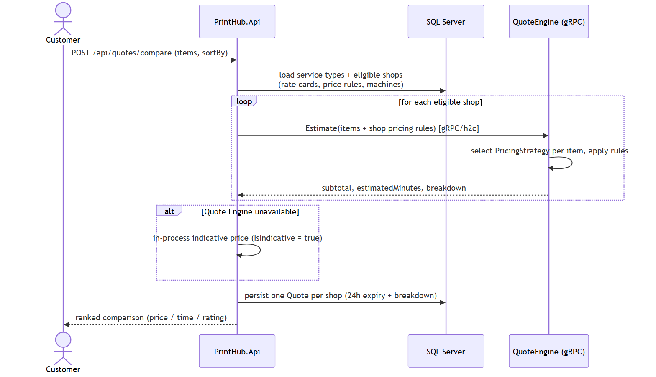

Quote Compare Sequence
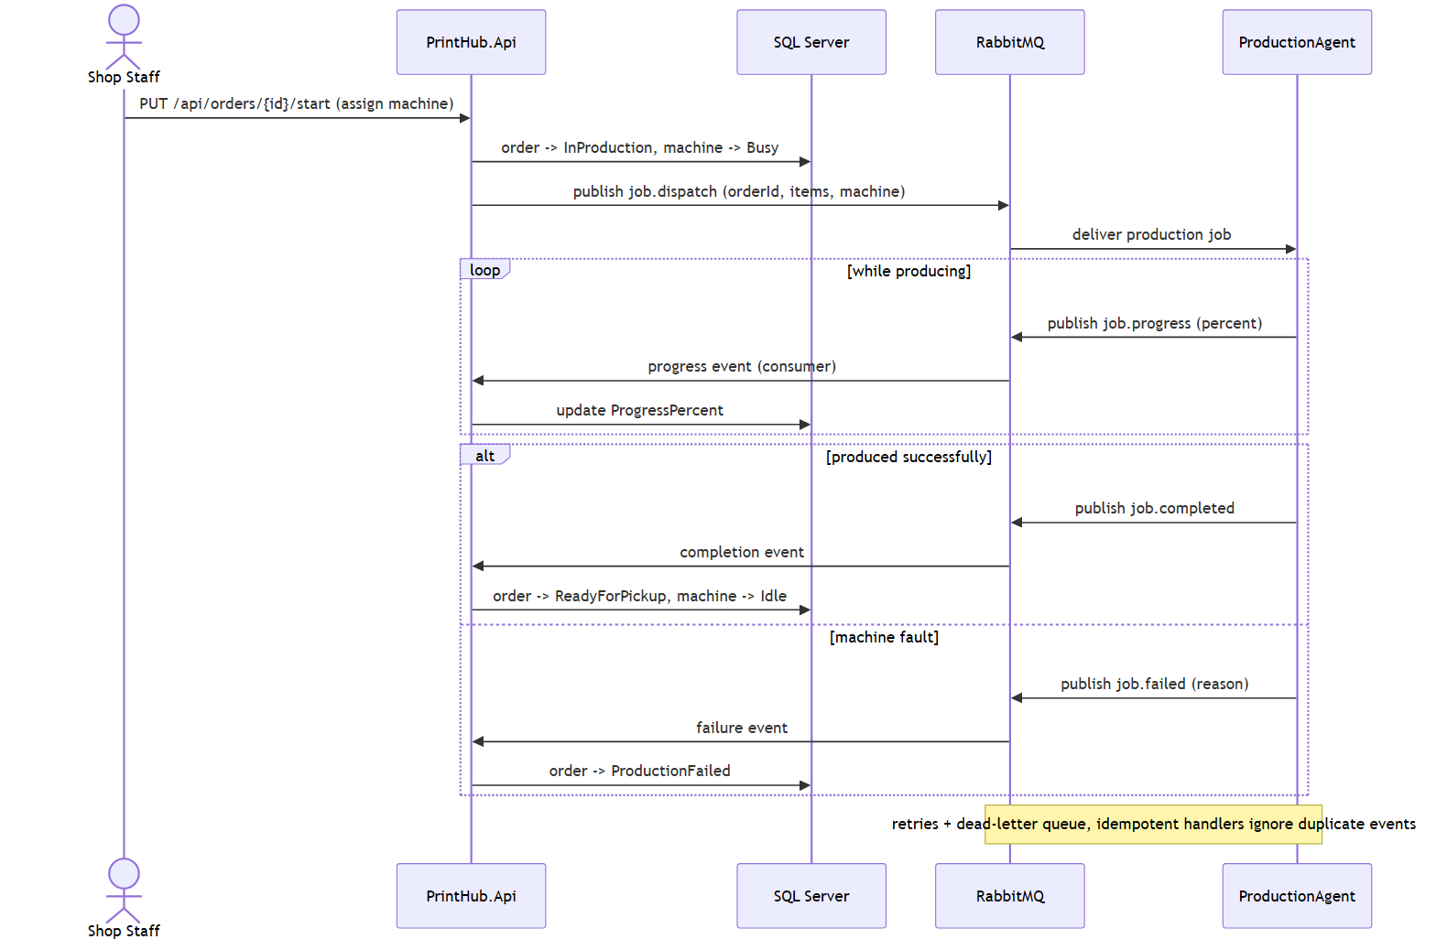
Order Production Sequence

14. Project Setup and Run Guide

14.1. Prerequisites
• .NET 8 SDK.
• Microsoft SQL Server LocalDB (or SQL Server Express / Developer).
• RabbitMQ (local install or CloudAMQP) for the production pipeline.
• Visual Studio 2022 / Rider / VS Code.

14.2. Solution Layout
PrintHub.sln
└─ src/
├─ PrintHub.Domain / Application / Infrastructure / Contracts
├─ PrintHub.Api # REST + OData (http://localhost:5080)
├─ PrintHub.QuoteEngine # gRPC (h2c) (http://localhost:5090)
├─ PrintHub.ProductionAgent # RabbitMQ worker
└─ PrintHub.Web / PrintHub.Desktop # MVC+JS client / WPF client

14.3. Configuration
{
"ConnectionStrings": {
"DefaultConnection": "Server=(localdb)\\MSSQLLocalDB;Database=PrintHubDb;Trusted_Connection=True;TrustServerCertificate=True"
},
"Jwt": { "Issuer": "PrintHub", "Audience": "PrintHubClients", "Key": "<dev-secret>", "AccessTokenMinutes": 15, "RefreshTokenDays": 7 },
"QuoteEngine": { "Address": "http://localhost:5090" }
}

14.4. Create the Database
dotnet ef database update --project src/PrintHub.Infrastructure --startup-project src/PrintHub.Infrastructure
# Or simply run the API once: migrations are applied and the seed runs on startup.
The seed creates 9 users (one per role plus shops/customers), 12 service types across the three pricing groups, 3 active shops with rate cards, machines and materials, vouchers, and sample orders for reports.

14.5. Run the Services
# Terminal 1 - gRPC Quote Engine:
dotnet run --project src/PrintHub.QuoteEngine # gRPC on :5090
# Terminal 2 - Main Web API:
dotnet run --project src/PrintHub.Api --urls http://localhost:5080
# Swagger: http://localhost:5080/swagger OData: http://localhost:5080/odata

14.6. Seeded Demo Accounts
Role | Email | Password
Admin | admin@printhub.vn | Password123!
Shop Owner | owner.quickprint@printhub.vn | Password123!
Shop Staff | staff.quickprint@printhub.vn | Password123!
Customer | customer1@printhub.vn | Password123!
These credentials are for local demonstration only; the seed stores BCrypt hashes, never plaintext.

15. Reports
Report | Metrics
Shop Revenue | Gross revenue, platform commission, net revenue, order count, and average order value by day/service group
Machine Utilisation & Failure | Production time per machine and the decline / cancellation / production-failure rate
Platform Summary | Transaction volume, revenue and commission, shop-performance ranking, and service mix - exportable as JSON, XML, or CSV

